

Write your name below:

_______________________________________________

**Hale School**

**Year 11 Semester 1 Examination, 2015**

**Mathematics   
Methods**

**Teacher:__________________________**

**Section One:  
Calculator-free**

**Booklet 1 of 3**

TIME ALLOWED FOR THIS SECTION

Reading time before commencing: Five minutes  
Working time for paper: Fifty minutes

**MATERIAL REQUIRED/RECOMMENDED FOR THIS PAPER**

|  |  |
| --- | --- |
| **For Examiners only** | |
| Section 1 |  |
| Section 2 |  |
| Total |  |

*TO BE PROVIDED BY THE SUPERVISOR*

This Question/Answer booklet.

Formula Sheet.

*TO BE PROVIDED BY THE CANDIDATE*

*Standard Items*: pens (blue/black preferred), pencils (including coloured), sharpener,   
 correction fluid/tape, eraser, ruler, highlighters

*Special Items*: nil

**IMPORTANT NOTE TO CANDIDATES**

No other items may be taken into the examination room. It is your responsibility to ensure that you do not have any unauthorised notes or other items of a non-personal nature in the examination room. Please check carefully, and if you have any unauthorised material with you, hand it to the supervisor **BEFORE** reading any further.

**STRUCTURE OF THIS PAPER**

|  |  |  |  |  |  |
| --- | --- | --- | --- | --- | --- |
| Section | Number of questions available | Number of questions to be answered | Working time (minutes) | Marks available | Percentage of exam |
| Section One:  Calculator-free | 9 | 9 | 50 | 50 | 37 |
| Section Two:  Calculator-assumed | 15 | 15 | 100 | 85 | 63 |
|  | | |  | **Total** | 100 |

**INSTRUCTIONS TO CANDIDATES**

1. Write your answers in this Question/Answer Booklet.
2. You must be careful to confine your responses to the specific questions asked and to follow any instructions that are specific to a particular question.
3. Spare pages are included at the end of this booklet. They can be used for planning your responses and/or as additional space if required to continue an answer.

● Planning: If you use the spare pages for planning, indicate this clearly at the top of the page.

● Continuing an answer: If you need to use the space to continue an answer, indicate   
 in the original answer space where the answer is continued, i.e. give the page number.

1. Fill in the number of the question that you are continuing to answer at the top of the page.
2. Show all your working clearly. Your working should be in sufficient detail to allow your answers to be checked readily and for marks to be awarded for reasoning. Incorrect answers given without supporting reasoning cannot be allocated any marks. For any question or part question worth more than two marks, valid working or justification is required to receive full marks. If you repeat any question, ensure that you cancel the answer you do not wish to have marked.
3. It is recommended that you do not use pencil, except in diagrams.

Section One: Calculator Free 50 marks (37%)  
This section has 8 questions. Answer all questions. Write your answers in the spaces provided.  
Working time: 50 minutes  
_______________________________________________________________________________

**Question 1 5 marks**

1. State the exact value of $\sin{(\frac{2π}{3})}$.
2. State the exact value of $\cos{(225°)}$.
3. Convert $18°$ to radians.
4. Determine the length of the minor arc AB shown below.



1. Factorise $x^{2}-7x+10$

**Question 2 3 marks**

State whether each of the following is a graph of a function or not.

1. 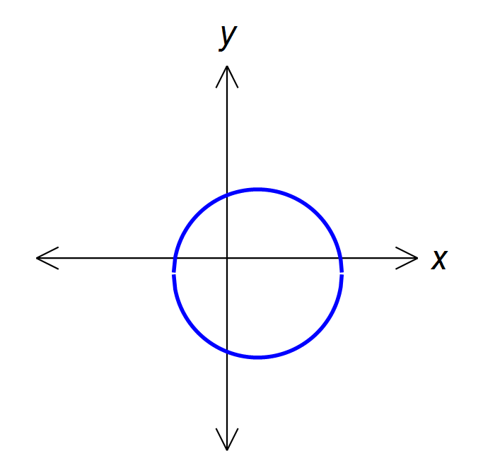





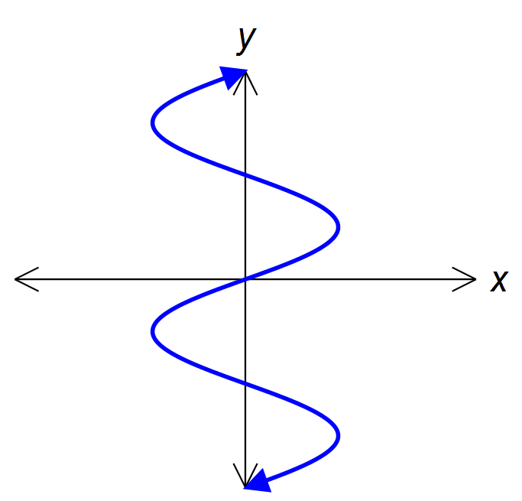

**Question 3 6 marks**

Some of the equations listed below match up to each of the graphs shown. Write the correct equation next to the relevant graph.

|  |  |  |  |
| --- | --- | --- | --- |
| A $y=x^{5}-10x^{4}-10x^{3}+200x^{2}+20x$ | | B $y=10x^{4}-10x^{3}+200x^{2}+20x$ | |
| C $y=(x-2)(x+3)$ | D $y=\frac{1}{x-3}+2$ | E $y={\left(x+2\right)}^{3}$ | F $y=-\sqrt{x-2}$ |
| G $y=(x+2)(x-3)$ | H $y=\frac{1}{x+3}+2$ | I $y={3x\left(x+2\right)}^{2}$ | J |

|  |  |
| --- | --- |
| a. | b. |
| c. | d. |
| e. | f. |

**Question 4 6 marks**

Solve each of the following equations for $x$.

1. $\frac{11x+7}{5}=7+3x$ (2 marks)
2. $3x^{2}=12x$ (1 mark)
3. $x^{2}+4x-3=0$ (3 marks)

**Question 5 6 marks**

State the equation of each graph shown below.

1. (3 marks)

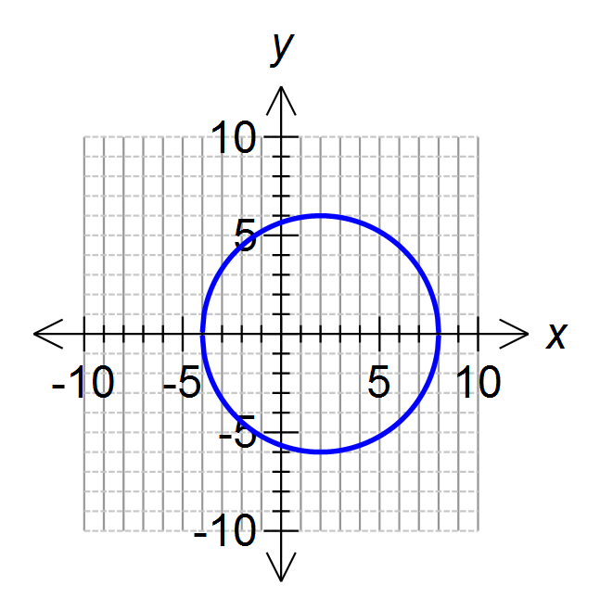

1. (3 marks)  
   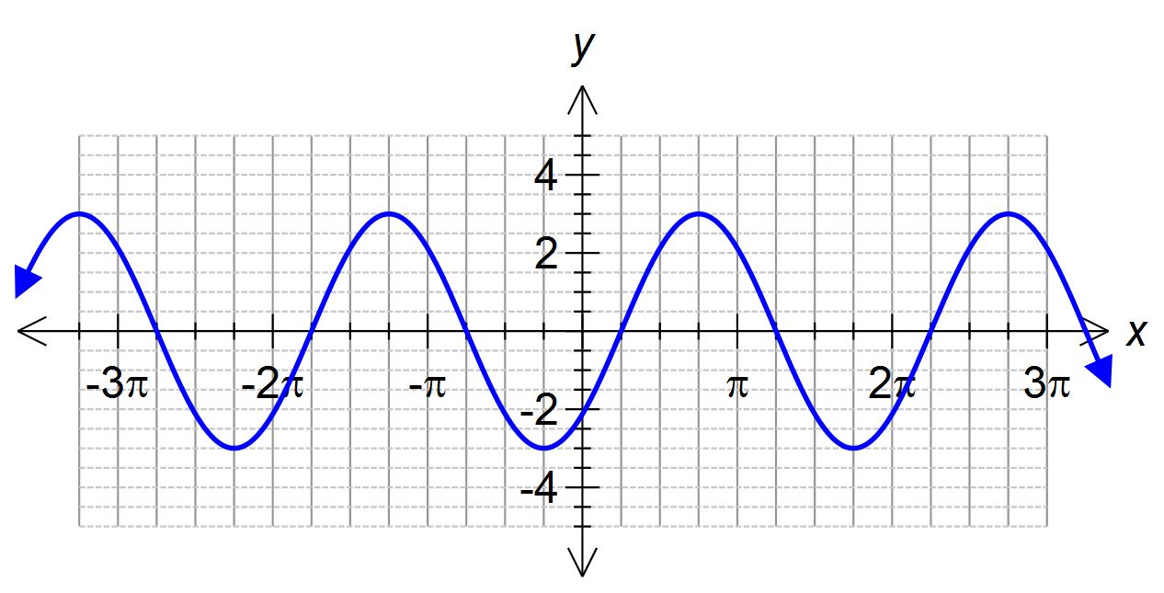

**Question 6 4 marks**

The first four rows of Pascal’s triangle are shown below.

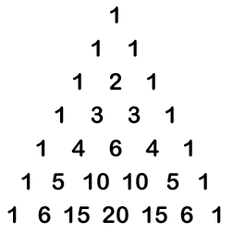

1. Expand the expression ${\left(x+3\right)}^{4}$, leaving terms in index form where necessary. (2 marks)
2. Fraser won a competition to take himself and 3 friends to the Grand Final. He has 6 close friends who want to go with him. How many different combinations of 3 friends are there for Fraser to choose from? (2 marks)

**Question 7 6 marks**

1. Solve $4\cos^{2}{x}-3=0 , for 0°≤x≤360°$ (3 marks)
2. Completely factorise the function $f(x)$ below, given that $f(3)=0$. (3 marks)

$$f\left(x\right)=x^{3}-6x^{2}-x+30$$

**Question 8 8 marks**

Jacob is on a treasure hunt but only has part of the map to guide him. He must walk from his starting point at the origin to each of the markers A, B and C, before reaching the treasure at X.   
The map below shows his starting point, the first marker at A and the second marker at B.



1. Jacob reaches point A and must travel to point B in a straight line. Determine the equation of the line passing through points A and B. (3 marks)

Jacob knows that points A, B and C lie in a straight line. When he reaches point B, he has travelled halfway along the line segment AC.

1. Determine the coordinates of point C. (2 marks)
2. To reach point X, Jacob must then travel along a line that is perpendicular to AB.   
   Determine the gradient of this line. (1 mark)

1. Harry is also on the treasure hunt and knows that the coordinates of the treasure at X are $( \frac{17}{2} , \frac{17\sqrt{3}}{2} )$ and decides to go straight there from the starting point. Determine the angle that the line Harry travels on will make with the x-axis on the map. (2 marks)

**Question 9 6 marks**

The function $f\left(x\right)=x^{2}-3kx+2k^{2}$ is defined for all $k∈R$.

1. If $k=2$, determine the coordinates of the $y$-intercept of $f(x)$. (1 mark)
2. If $k=3$, determine the coordinates of the $x$-intercepts of $f(x)$. (2 marks)
3. For what values of $k$ will $f\left(x\right)=0$ have 2 solutions? Justify your answer. (3 marks)

**END OF SECTION ONE**

This page may be used for extra working space:

Question: ______

This page may be used for extra working space:

Question: ______

This page may be used for extra working space:

Question: ______